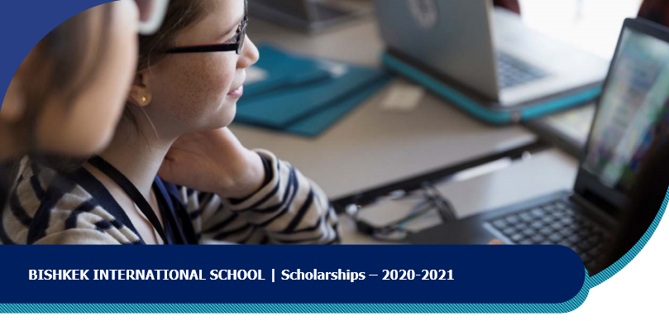

SCHOLARSHIP ANNOUNCEMENT
50% to 90% fee discount
Open to Students currently in Grade 9 or Grade 10

OBJECTIVES
- To develop students with a well-rounded education and leadership skills for the future.
- To provide the best students in the country with excellent international education so that they can qualify to enter top universities worldwide.
ESSENTIAL QUALIFICATIONS FOR SCHOLARSHIP
- Students must be in Grade 9 or Grade 10 at the time of application.
- Must pass exams in English and Math, to prove English language and numeracy skills.
- Must pass an interview with BIS to confirm English language skills and a positive approach to learning.
- Must demonstrate financial need for a scholarship.
SCHOLARSHIP BENEFITS
50% to 90% discount scholarship from the full school fee for Grade 10 (if applicable), Grade 11 and Grade 12 to complete the International Baccalaureate Diploma Program http://www.ibo.org/programmes/diploma-programme/

DURATION
Scholarships start in August 2020 and continue until leaving BIS after Grade 12, provided scholars maintain high academic and social standards while at school.
APPLICATION AND AWARD PROCESS
- Submit your Application.
- Fill in the application form below and send the completed form by email attachment to admissions@bis.kg OR deliver a hard copy to BIS, including these documents:
- Completed application form
- Copy of passport
- Copy of the most recent school report (if there any available)
All applications will be treated in confidence.
- First examination and interview will take place at BIS will be announced.
- Short-listed candidates will be asked to complete and submit a Family Income Declaration form.
- Award of scholarship and amount of scholarship is dependent on financial need for a scholarship.
Scholarship award decisions will be announced. You will be notified by email.

SCHOLARSHIP APPLICATION FORM
Student Information
First Name |  | Family Name
Date of Birth |  | Citizenship
Current School and Current Year Grade |  | Previous Schools (years)
Phone number |  | Email address
Contact information and confirmation from one parent or guardian
First Name |  | Family Name
Relationship to this student (e.g. Mother) |  | Phone Numbers
Email address
Home Address
I confirm that I am proposing the child named above to be considered for the BIS scholarship program. I confirm that they are ready to take an examination at BIS in English and Mathematics as appropriate for their age group. I confirm that all of the information entered by me on this application form is correct. I confirm that I will accept any decision of BIS about award of scholarship or refusal to offer scholarship, without any disagreement from my side. I confirm that if a scholarship is awarded, I am able to complete the enrolment process and pay part of the full school fees from my own funds or from other financial sources that are committed to this purpose.
Signature for confirmation
(or just retype your name here if you are completing this form on your computer)
Other Information
How did you find out about this scholarship?
Any other comments or extra information?

Send your completed form by email attachment to admissions@bis.kg OR deliver a hard copy to BIS, together with:

- Copy of child’s passport showing birthdate and citizenship
- Copy of child’s most recent school report – if available

Contact information: admissions@bis.kg www.bis.kg 0312 214 406 / 0706 200 200 67 A Bronirovannaya St.
OFFICE USE ONLY |  |  |  | Exam Date
Date application received |  | Year group applied for |  | Result

Must be 16 OR 17 years old on 1st September 2020 and finished Grade 9 or 10 in local school. Special exceptions are possible.
2 The scholarship discount will be removed in case of poor academic performance or discipline or late payment of fees.

